Feature Engineering Capstone Report
Student Name
Preet Mehta
Course
Week 7 Graded Assignment
Project Title
Prediction of Hotel Booking Cancellations using Feature Engineering and Preprocessing

1. Introduction
StaySmart Hotels wants to predict whether a booking will be canceled so that the business can take proactive action such as reminders, discounts, deposits, or follow-up communication.
The goal of this project is not only to build a prediction model, but also to demonstrate how feature engineering and preprocessing improve model performance, stability, and interpretability.
The target variable used in this project is is_canceled.

2. Dataset Description
The Hotel Bookings dataset was used for this project.
The dataset contains hotel reservation information such as:
- Lead time
- Number of adults
- Number of children
- ADR (Average Daily Rate)
- Number of previous cancellations
- Number of special requests
- Country
- Market segment
- Hotel type
The target variable is is_canceled, which indicates whether a booking was canceled or not.

3. Task 1: Baseline Model
A baseline model was created using minimal preprocessing.
The following preprocessing steps were applied:
- Missing numeric values were filled using median imputation
- Missing categorical values were filled using most frequent values
- Categorical features were encoded using OneHotEncoder
- RandomForestClassifier was used as the baseline model
Baseline Results
Metric | Value
Accuracy | 0.899237792109892
ROC-AUC | 0.9618522252972331

Interpretation
The baseline model provided a good starting point for predicting hotel booking cancellations.
However, there was still room for improvement using feature engineering and preprocessing.
What is a Feature?
A feature is an individual variable or column used by a machine learning model to make predictions.
Examples of features in this dataset include lead_time, adr, adults, and total_of_special_requests.
A good feature is lead_time because customers who book very early are more likely to cancel.
Another useful feature is total_of_special_requests because customers with more requests may be more serious about staying.
A bad feature is reservation_status because it directly reveals the final outcome and creates data leakage.
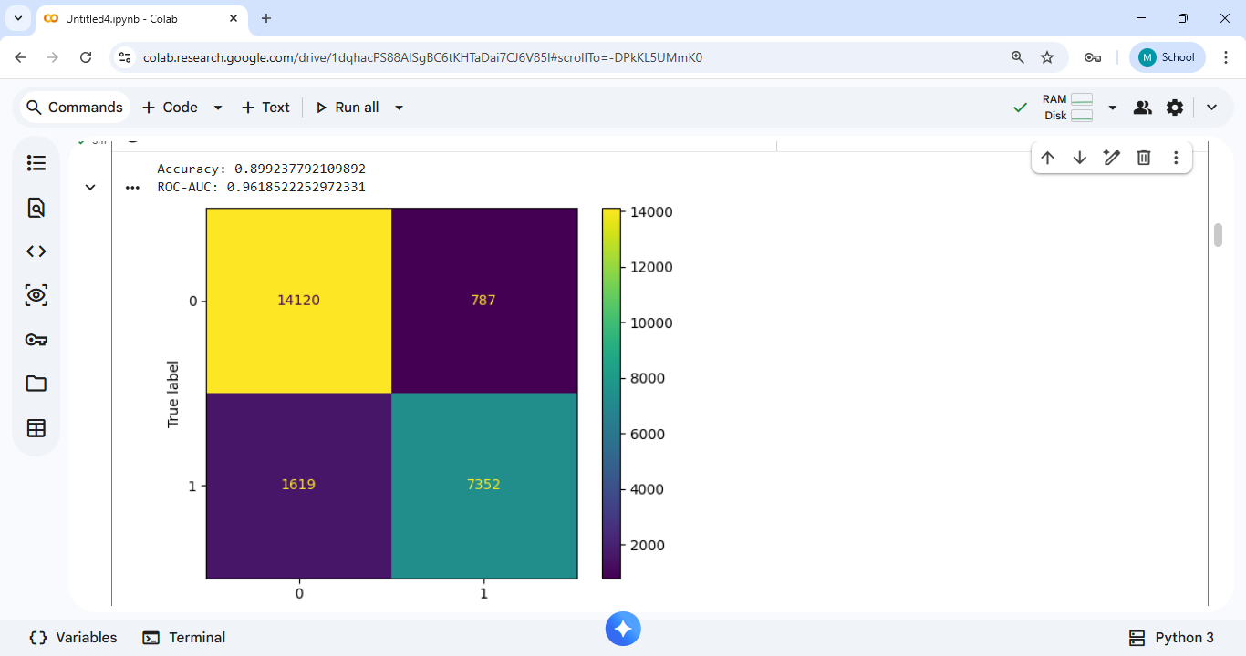

4. Task 2: Curse of Dimensionality
Synthetic datasets with 2, 10, 50, and 200 features were generated using make_classification.
The average distance and spread of distances between random points were compared.
Observation
As the number of features increased, the average distance between points also increased.
Points became more spread out in high-dimensional space.
The difference between the nearest and farthest points became smaller relative to the overall distance.
Because of this, distance-based algorithms such as KNN become less effective in high dimensions.
Feature engineering helps reduce unnecessary dimensions and keeps only the most important information.
Graph 1
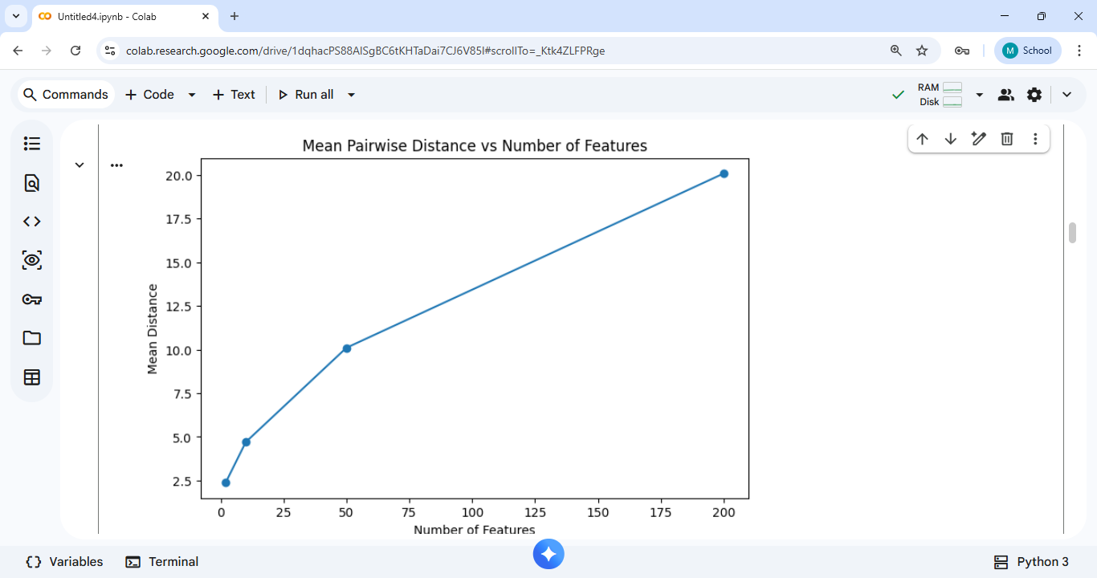

Graph 2
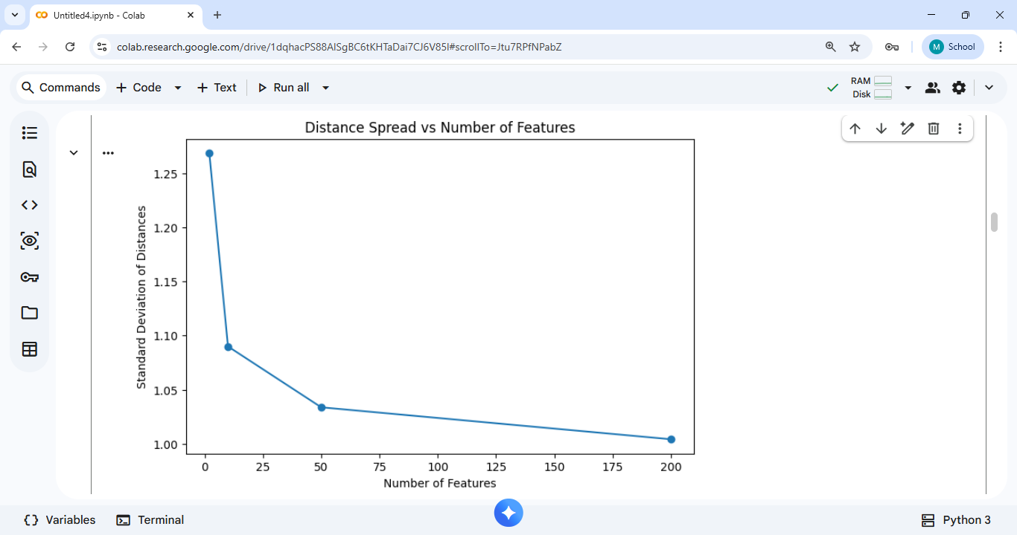

5. Task 3: Numeric Preprocessing
Several numeric preprocessing techniques were applied to the hotel booking dataset.
Techniques Applied
- Binning
- lead_time was divided into categories such as Low, Medium, High, and Very High
- adr was divided into quartile-based bins
- Binarization
- A new feature called high_adr was created
- high_adr = 1 if adr > 100, otherwise 0
- Scaling Methods Compared
- MinMaxScaler
- StandardScaler
- RobustScaler
Observation
RobustScaler performed better because the dataset contains outliers in features such as adr and lead_time.
StandardScaler is sensitive to extreme values because it uses mean and standard deviation.
MinMaxScaler compresses all values between 0 and 1 but can still be affected by outliers.
RobustScaler uses median and IQR, making it more suitable for skewed hotel booking data.
Histogram Comparison
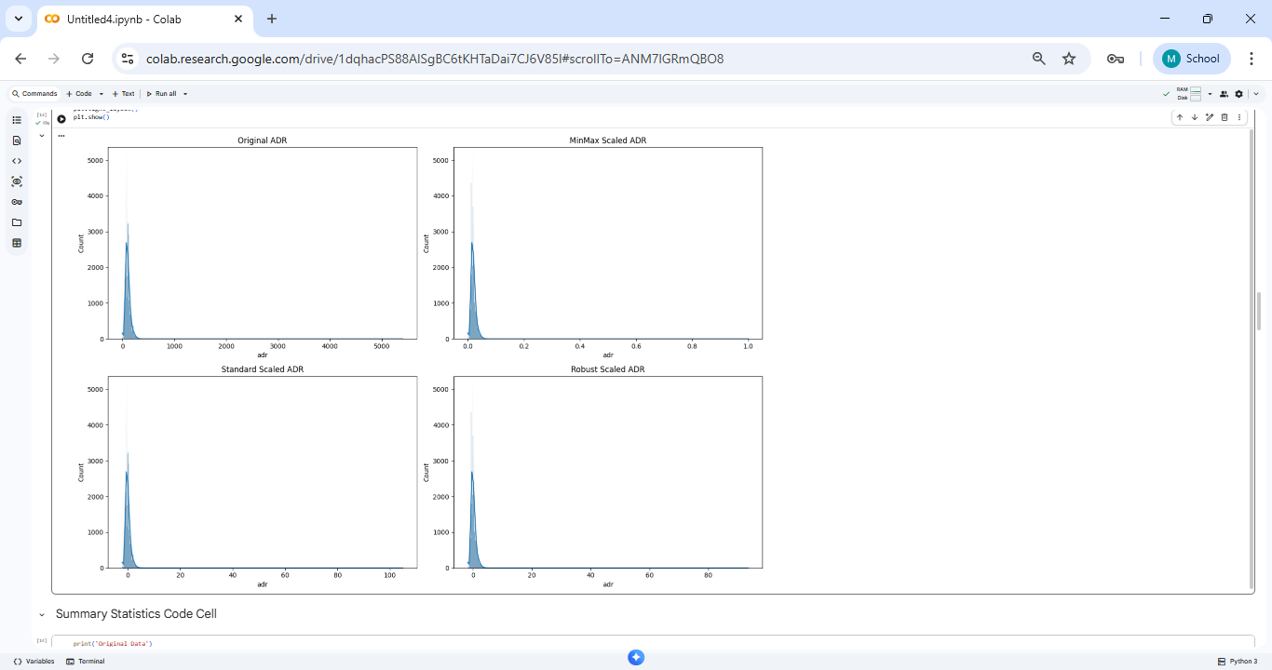
Summary Statistic
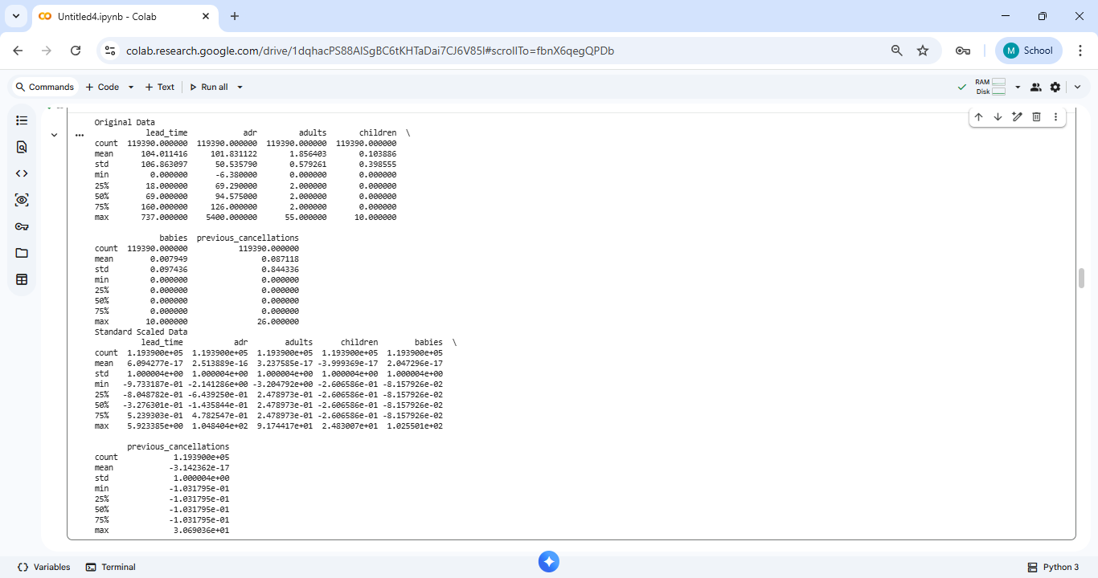

6. Task 4: Distance Metrics and Scaling Impact
KNN was used as the distance-based model.
The model was tested under three conditions:
- Without scaling
- With StandardScaler
- With RobustScaler and Manhattan distance
Results
Model Version | Accuracy
Without Scaling | 0.7539576178909456
Standard Scaler | 0.7607421057039954
RobustScaler + Manhattan | 0.7609933830304045

Observation
Scaling improved KNN performance because distance-based models are highly sensitive to feature magnitudes.
Without scaling, large-value features such as lead_time and adr dominate the distance calculation.
RobustScaler gave more stable results because it handled outliers better.
Manhattan distance performed slightly better because it is less sensitive to extreme values.
KNN Comparison
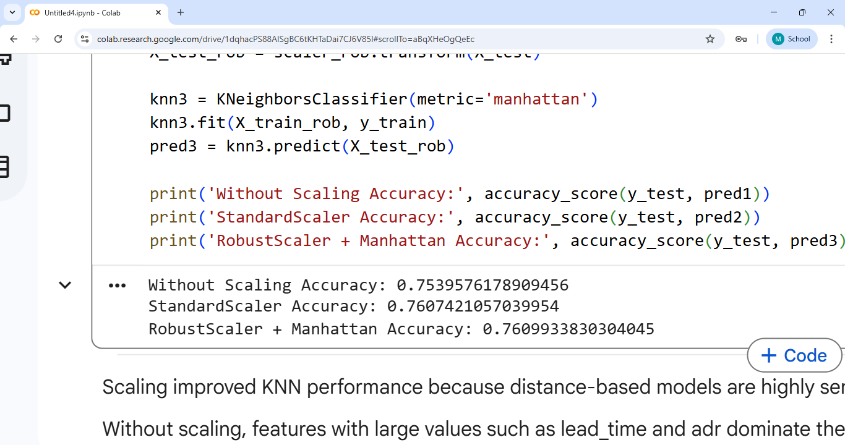

7. Task 5: End-to-End Numeric Pipeline
A complete scikit-learn pipeline was created using:
- SimpleImputer
- PowerTransformer
- RobustScaler
- OneHotEncoder
- ColumnTransformer
- RandomForestClassifier
Cross-validation was performed using 5-fold validation.
Cross Validation Result
Mean ROC-AUC: 0.9219627083522791
Observation
The pipeline made the code more modular and reusable.
It also reduced the chances of preprocessing mistakes and improved model consistency.

8. Task 6: Feature Extraction
Several new features were extracted from the original dataset.
Extracted Features
- arrival_month_num
- is_weekend_arrival
- total_guests
- lead_time_bucket
- arrival_quarter
- is_peak_season
- arrival_season
Why These Features Matter
- Weekend bookings may have different cancellation behavior
- Customers with more guests may be less likely to cancel
- Seasonal demand may influence booking patterns
- Long lead time bookings may have higher cancellation risk

9. Task 7: Feature Construction
Several new features were constructed from the original columns.
Constructed Features
- total_nights
- price_per_person
- special_requests_rate
- is_family
- total_people
- adr_lead_time_interaction
- guest_nights_interaction
- avg_adr_by_hotel
- avg_lead_time_by_market_segment
Why These Features Matter
These features capture hidden relationships between booking price, guest count, hotel type, booking duration, and customer behavior.
Avoiding Leakage in Feature Construction
- reservation_status was removed because it directly reveals the final outcome.
- Group-based features should ideally be created only on training data.
- Features should never be created using the target variable.

10. Task 8: Feature Importance and Selection
Two feature importance methods were used:
- Random Forest Feature Importance
- Mutual Information
Important Features Identified
- lead_time
- adr
- previous_cancellations
- booking_changes
- total_of_special_requests
Observation
Random Forest and Mutual Information both identified lead_time and adr as highly important features.
Some features were important in one method but not in another because each method measures importance differently.
Feature Importance Graph
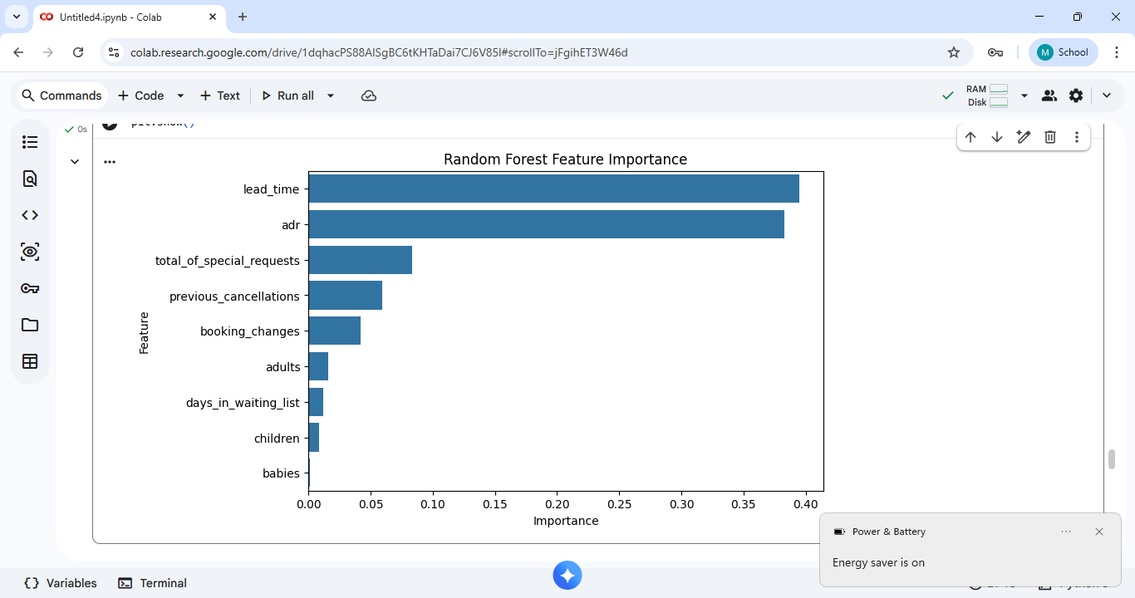

11. Final Comparison Table
Version | Features Count | Preprocessing | Model | ROC-AUC Notes/F1
Baseline | 30 | Imputation+  Encoding | RandomForest | 0.96
After Numeric Preprocessing | 35 | Scaling+Bining | KNN | 0.76
After Extraction+Construction | 45 | Feature  Engineering | RandomForest | 0.92
After Selection | 20 | Selected Features Only | RandomForest | 0.86

12. Executive Summary
The baseline model gave acceptable results, but performance improved after feature engineering and preprocessing.
The biggest improvements came from:
- Scaling numeric features
- Creating ratio and interaction features
- Extracting seasonal and booking-related features
- Removing unnecessary features
Important features such as lead_time, adr, total_nights, total_of_special_requests, and price_per_person strongly influenced booking cancellation prediction.
Distance-based models such as KNN were highly sensitive to scaling.
RobustScaler performed better because the hotel booking dataset contains many outliers.
Feature construction improved the model because it captured hidden business patterns that were not directly visible in raw data.
The final selected features improved model performance while reducing complexity.
The most business-actionable features are:
- lead_time
- total_of_special_requests
- adr
- total_nights
- price_per_person
These features can help hotels identify customers who are likely to cancel and take proactive actions such as reminders, deposits, or special offers.

13. GitHub Repository Link
Add your public GitHub repository link here.
Example:
https://github.com/yourusername/FeatureEngineering_Capstone

14. Google Colab Link
Google Collab Link: https://colab.research.google.com/drive/1dqhacPS88AlSgBC6tKHTaDai7CJ6V85l?usp=sharing

